1.odd string difference

Code:

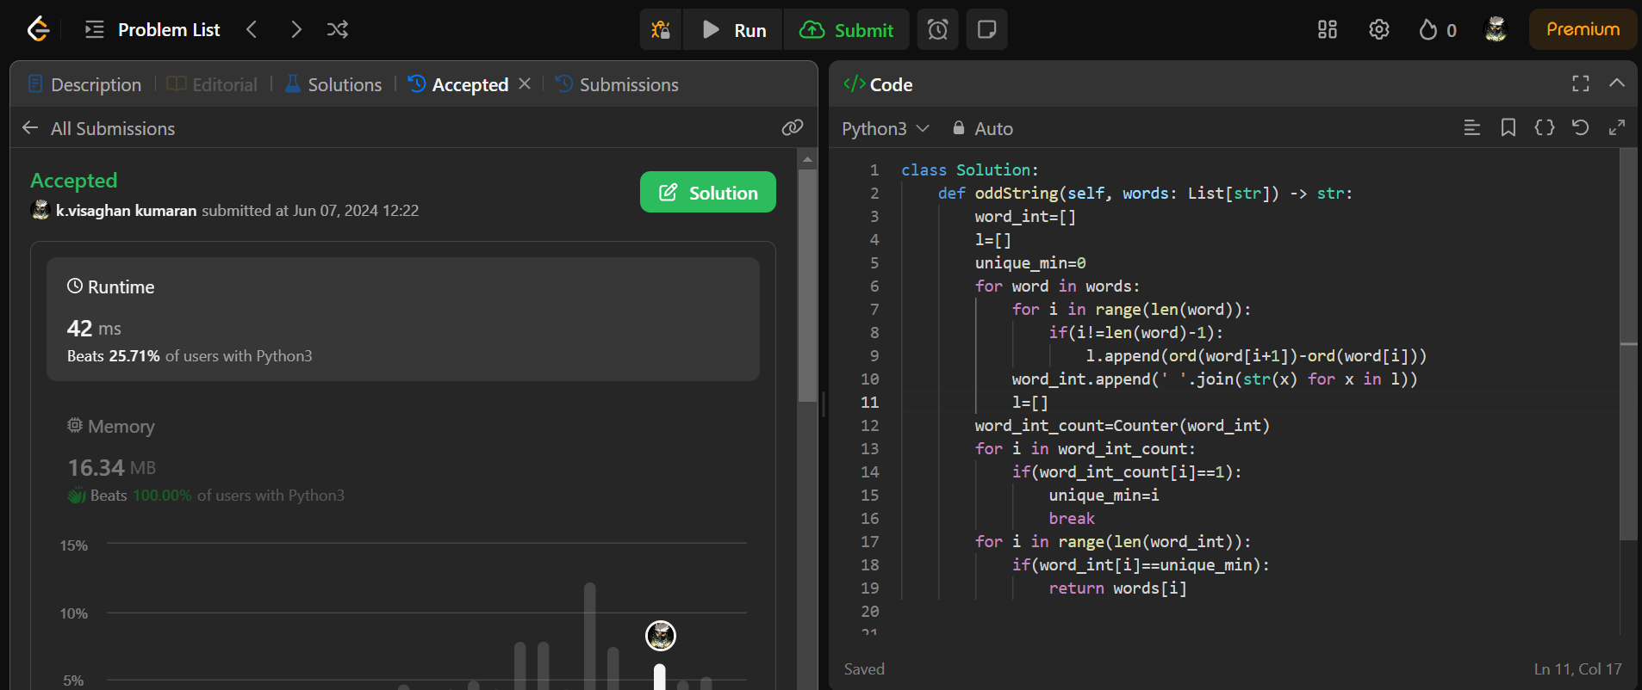

Time complexity= O(n)

2.words within two words of dictionary

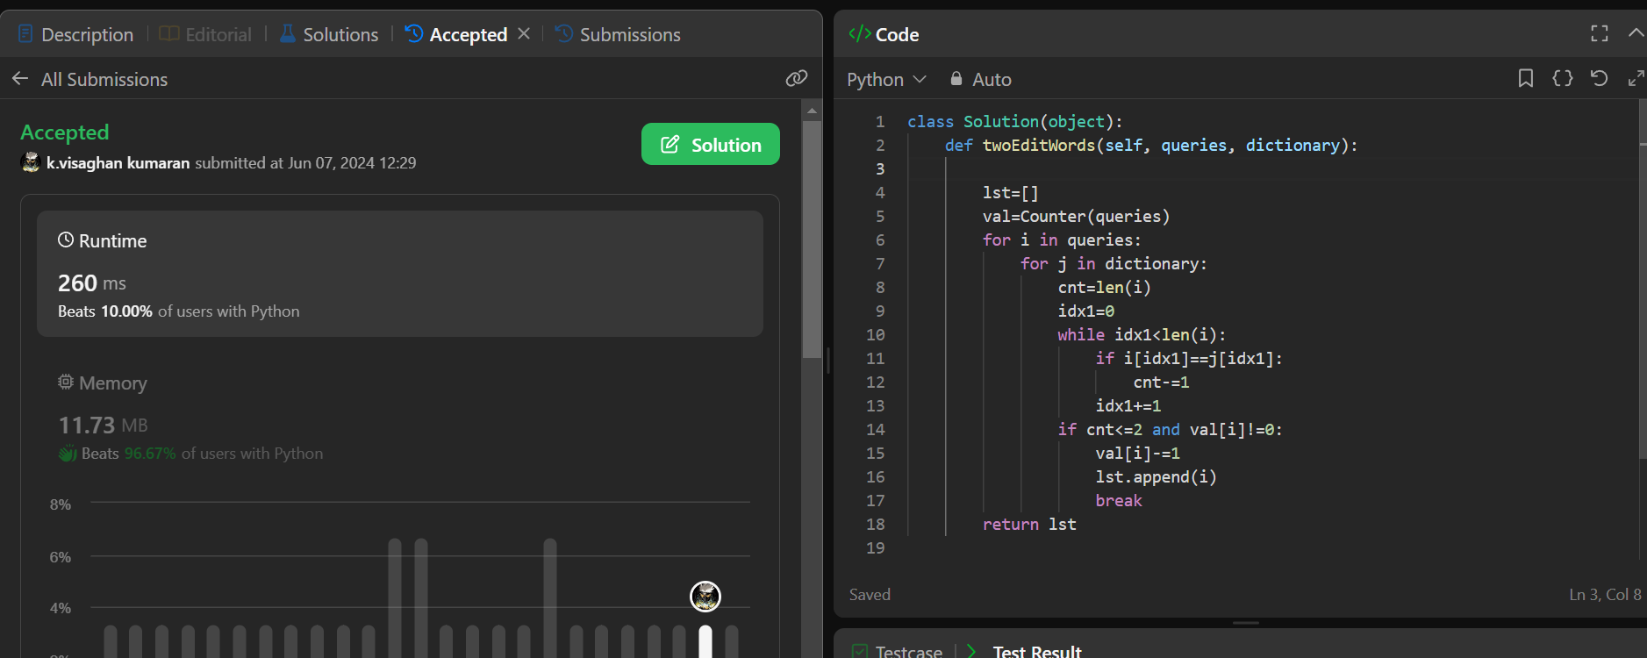

Time complexity: O(n^2)

3.next greatest element IV

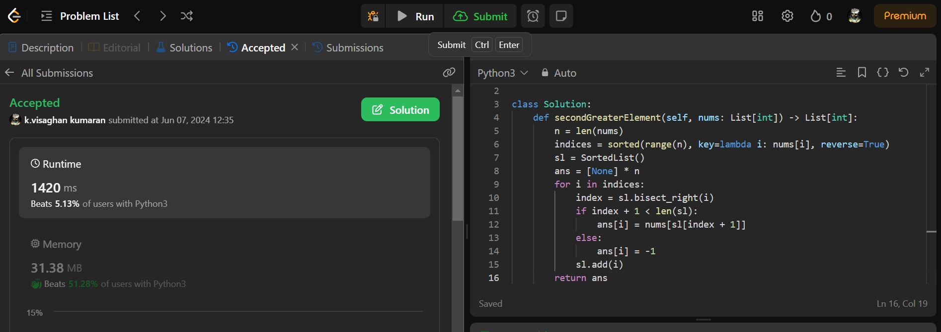

Time complexity: O(n^2)

4. Minimum Addition to make integer beautiful

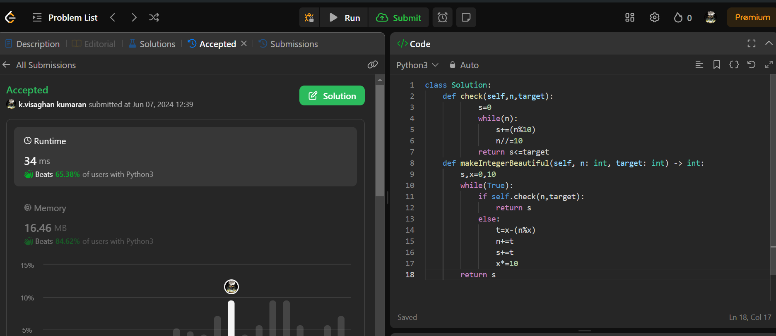

Time complexity: O(n)

5. sort array by moving items to empty space

